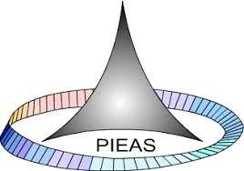

**PAKISTAN INSTITUTE OF ENGINEERING AND APPLIED SCIENCES**

***Computing Fundamentals & Programming***

**FALL 2020**

Laboratory Exercise-08

Name: Umar Shifaqat

Department: PHYSICS

Roll No. BS-20-GB-100864

Date: NOVEMBER 23, 2020

**HOME TASKS**

**HOME TASK 01**

**Write a program in C to store elements in an array and print it.**

**INPUT**

#include<stdio.h>

int main()

{

int i,array[6];

printf("Eneter 6 elements in the array: \n");

for(i=1;i<=6;i++)

{

printf("\nElement %d: ",i);

scanf("%d",&array[i-1]);

}

printf("\nElements in array are:");

for(i=0;i<6;i++)

printf(" %d ",array[i]);

getchar();

getchar();

return 0;

}

**OUTPUT**

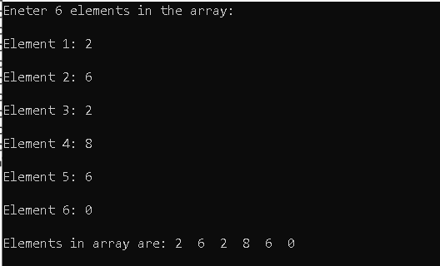

**HOME TASK 02**

**Write a program in C to read n number of values in an array and display it in reverse order.**

**INPUT**

#include<stdio.h>

int main()

{

int i,n,array[100];

printf("\nEnter the No. of Elements to store in the array: ");

scanf("%d",&n);

printf("\nEneter %d elements in the array: \n",n);

for(i=0;i<n;i++)

{

printf("\nElement %d: ",i+1);

scanf("%d",&array[i]);

}

printf("\nValues stored in array are:");

for(i=0;i<n;i++)

printf(" %d ",array[i]);

printf("\n\nThe Stored values in reverse order are:");

for(i=n-1;i>=0;i--)

printf(" %d ",array[i]);

getchar();

getchar();

return 0;

}

**OUTPUT**

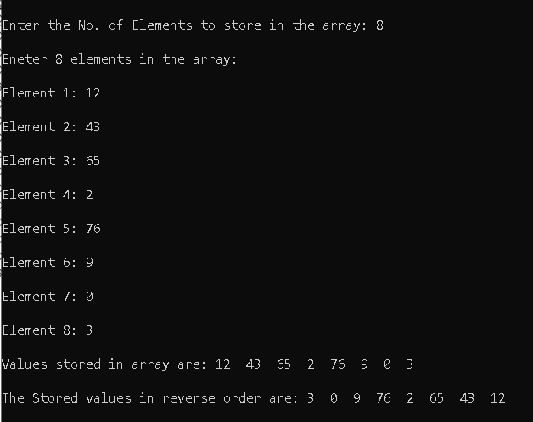

**HOME TASK 03**

**Write a program in C to copy the elements of one array into another array.**

**INPUT**

#include<stdio.h>

int main()

{

int array[100],copy[100];

int i,n;

printf("\nEnter the No. of Elements to store in the array: ");

scanf("%d",&n);

printf("\nEneter %d elements in the array: \n",n);

for(i=0;i<n;i++)

{

printf("\nElement %d: ",i+1);

scanf("%d",&array[i]);

}

for(i=0;i<n;i++)

copy[i]=array[i];

printf("\n\nElements stored in 1st array are:");

for(i=0;i<n;i++)

printf(" %d ",array[i]);

printf("\n\nThe Elements copied in 2nd array are:");

for(i=0;i<n;i++)

printf(" %d ",copy[i]);

getchar();

getchar();

return 0;

}

**OUTPUT**

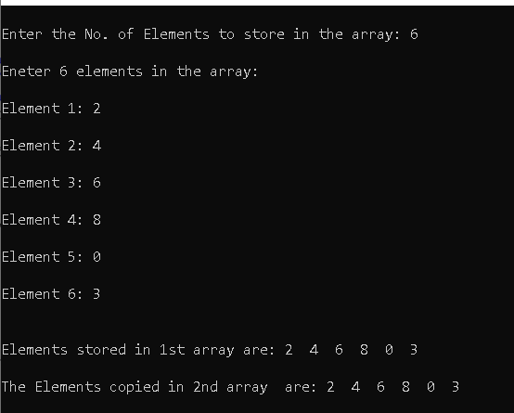

**HOME TASK 04**

**Write a program in C to count a total number of duplicate elements in an array.**

**INPUT**

#include<stdio.h>

int main()

{

int array[100];

int i,j,n,duplicate=0;

printf("\nEnter the No. of Elements to store in the array: ");

scanf("%d",&n);

printf("\nEneter %d elements in the array: \n",n);

for(i=0;i<n;i++)

{

printf("\nElement %d: ",i+1);

scanf("%d",&array[i]);

}

for(i=0;i<n;i++)

{

for(j=0;j<n;j++)

{ if(i!=j && array[i]==array[j])

duplicate++;

}

}

printf("\n\nThe total number of duplicate elements are: %d",duplicate/2);

getchar();

getchar();

return 0;

}

**OUTPUT**

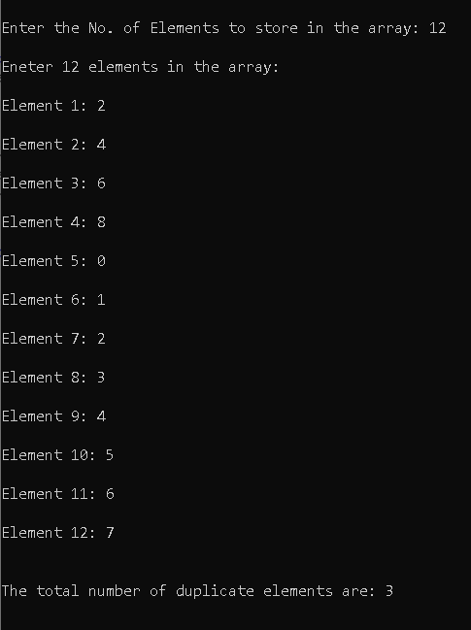

**HOME TASK 05**

**Write a program in C to print all unique elements in an array.**

**INPUT**

#include<stdio.h>

int main()

{

int array[100];

int i,j,n,uniq;

printf("\nEnter the No. of Elements to store in the array: ");

scanf("%d",&n);

printf("\nEneter %d elements in the array: \n",n);

for(i=0;i<n;i++)

{

printf("\nElement %d: ",i+1);

scanf("%d",&array[i]);

}

printf("\n\nThe Unique elements in Array are: ");

for(i=0;i<n;i++)

{

uniq=1;

for(j=0;j<n;j++)

{

if(j!=i&&array[i]==array[j])

uniq=0;

}

if(uniq==1)

{ printf(" %d ",array[i]); }

}

getchar();

getchar();

return 0;

}

**OUTPUT**

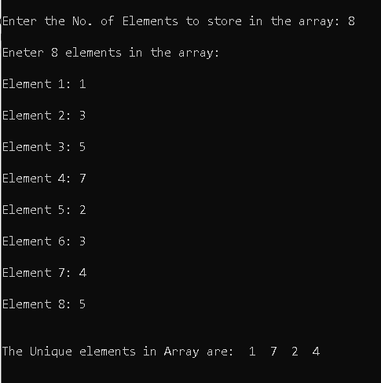

**HOME TASK 06**

**Write a program in C to merge two arrays of same size sorted in descending order.**

**INPUT**

#include<stdio.h>

int main()

{

int array1[100],array2[100],merge[100];

int i,j,x,n1,n2,n;

printf("\nEnter the No. of Elements to store in the array1: ");

scanf("%d",&n1);

printf("\nEneter %d elements in the array: \n",n1);

for(i=0;i<n1;i++)

{

printf("\nElement %d: ",i+1);

scanf("%d",&array1[i]);

}

printf("\nEnter the No. of Elements to store in the array2: ");

scanf("%d",&n2);

printf("\nEneter %d elements in the 2nd array: \n",n2);

for(i=0;i<n2;i++)

{

printf("\nElement %d: ",i+1);

scanf("%d",&array2[i]);

}

n=n1+n2;

for(i=0;i<n1;i++)

merge[i]=array1[i];

for(j=0;j<n2;j++,i++)

merge[i]=array2[j];

for(i=0;i<n;i++)

{

for(j=0;j<n-1;j++)

{

if(merge[j]<merge[j+1])

{

x=merge[j+1];

merge[j+1]=merge[j];

merge[j]=x;

}

}

}

printf("\nThe merged array in descending order is: ");

for(i=0;i<n;i++)

printf(" %d ",merge[i]);

getchar();

getchar();

getchar();

return 0;

}

**OUTPUT**

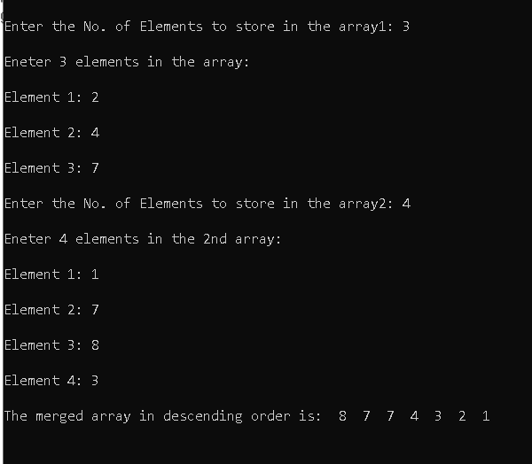

**HOME TASK 07**

**Write a program in C to find the missing number from a given array. There are no duplicates in list.**

**INPUT**

#include<stdio.h>

int main()

{

int array[100];

int i,j,k,n,missing;

printf("\nEnter the number of elements of the array: ");

scanf("%d",&n);

printf("\nEnter the Elements of the array:\n");

for(i=0;i<n;i++)

{

printf("\nElement %d: ",i+1);

scanf("%d",&array[i]);

}

for(i=0;i<n;i++)

{

for(j=0;j<n-1;j++)

{

if(array[j]>array[j+1])

{

k=array[j+1];

array[j+1]=array[j];

array[j]=k;

}

}

}

printf("\n The Elements of the array are : ");

for(i=0;i<n;i++)

printf(" %d", array[i]);

for(i=0,k=1;i<n;i++,k++)

{ if(array[i]!=k)

{

missing=k;

break;

}

}

printf("\nThe missing term is %d.",missing);

getchar();

getchar();

getchar();

return 0;

}

**OUTPUT**

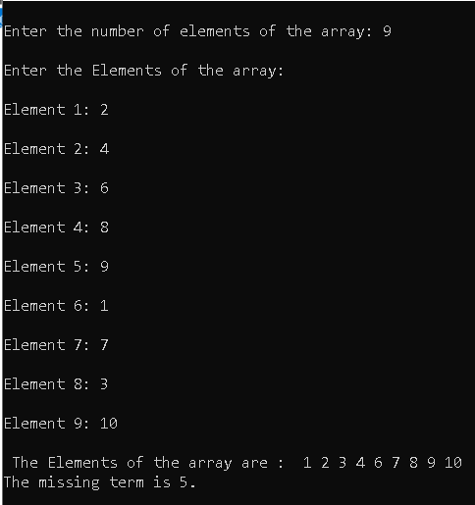

**HOME TASK 08**

**Write a program in C to check whether a matrix provided by user is identity matrix or not?**

**INPUT**

#include<stdio.h>

int main()

{

int mat[100][100];

int i,j,n,identity;

printf("Enter the number of coulomns/rows of the square matrix: ");

scanf("%d",&n);

printf("Enter the elements of %d-by-%d square matrix: \n",n,n);

for(i=0;i<n;i++)

{ printf("Row-%d:\n",i+1);

for(j=0;j<n;j++)

scanf("%d",&mat[i][j]);

}

printf("The entered matrix is : ");

for(i=0;i<n;i++)

{ printf("\n\t");

for(j=0;j<n;j++)

printf(" %d",mat[i][j]);

}

identity=1;

for(i=0;i<n;i++)

{

for(j=0;j<n;j++)

{

if(i==j && mat[i][j]!=1)

{ identity=0;

break;

}

if(i!=j && mat[i][j]!=0)

{ identity=0;

break;

}

}

}

if(identity==1)

printf("\nThe matrix is identity");

else

printf("\nThe matrix is not identity");

getchar();

getchar();

getchar();

return 0;

}

**OUTPUT**

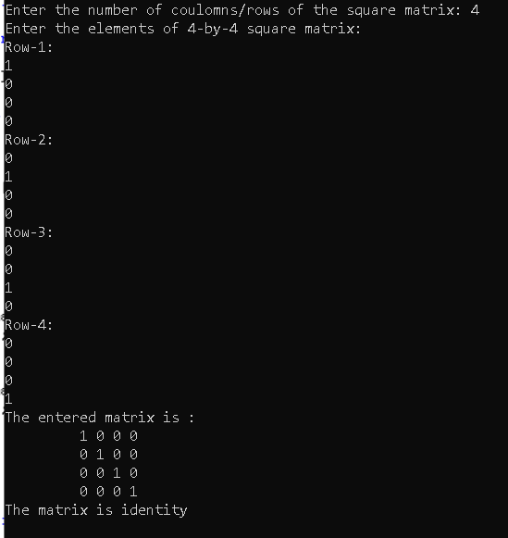

**HOME TASK 09**

**Write a C program to check whether a matrix provided by user is scalar matrix or not?**

**INPUT**

#include<stdio.h>

int main()

{

int mat[100][100];

int i,j,n,k,scalar;

printf("Enter the number of coulomns/rows of the square matrix: ");

scanf("%d",&n);

printf("Enter the elements of %d-by-%d square matrix: \n",n,n);

for(i=0;i<n;i++)

{ printf("ROW-%d:\n",i+1);

for(j=0;j<n;j++)

scanf("%d",&mat[i][j]);

}

printf("The entered matrix is : ");

for(i=0;i<n;i++)

{ printf("\n\t");

for(j=0;j<n;j++)

printf(" %d",mat[i][j]);

}

scalar=1;

k=mat[0][0];

for(i=0;i<n;i++)

{

for(j=0;j<n;j++)

{

if(i==j && mat[i][j]!=k)

{ scalar=0;

break;

}

if(i!=j && mat[i][j]!=0)

{ scalar=0;

break;

}

}

}

if(scalar==1)

printf("\nThe matrix is scalar");

else

printf("\nThe matrix is not scalar");

getchar();

getchar();

getchar();

return 0;

}

**OUTPUT**

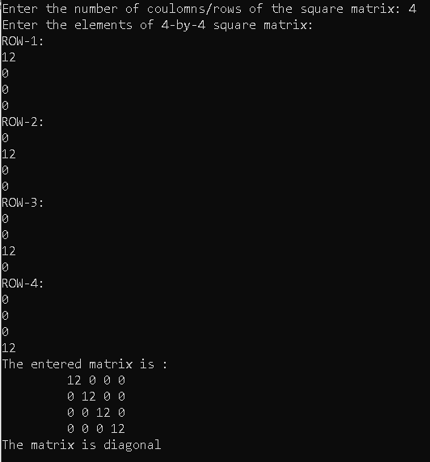

**HOME TASK 10**

**Write a C program to check whether a matrix provided by user is diagonal matrix or not?**

**INPUT**

include<stdio.h>

int main()

{

int mat[100][100];

int i,j,n,diagonal;

printf("Enter the number of coulomns/rows of the square matrix: ");

scanf("%d",&n);

printf("Enter the elements of %d-by-%d square matrix: \n",n,n);

for(i=0;i<n;i++)

{ printf("ROW-%d:\n",i+1);

for(j=0;j<n;j++)

scanf("%d",&mat[i][j]);

}

printf("The entered matrix is : ");

for(i=0;i<n;i++)

{ printf("\n\t");

for(j=0;j<n;j++)

printf(" %d",mat[i][j]);

}

diagonal=0;

for(i=0;i<n;i++)

{

for(j=0;j<n;j++)

{

if(i==j && mat[i][j]!=0)

diagonal=1;

if(i!=j && mat[i][j]!=0)

{ diagonal=0;

break;

}

}

}

if(diagonal==1)

printf("\nThe matrix is diagonal");

else

printf("\nThe matrix is not diagonal");

getchar();

getchar();

getchar();

return 0;

}

**OUTPUT**

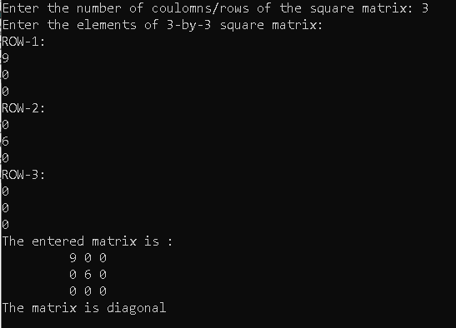

***THE END***